**Software Requirement Specification**

***Insurance Management - POC***

Document Number: INC-MS-1056

Document Version: 0.5

|  |
| --- |
|  |
|  |

*Proprietary & Confidential*

**Copyright 2016 - 2017 INCEDO INC**. All Rights Reserved. No part of this document may be reproduced, stored in a retrieval system, distributed or transmitted, in any form, or by any means, electronic or otherwise, including photocopying, reprinting, or recording, for any purpose, without the express prior written permission of Incedo Inc.

**REQUESTS** For information requests or for obtaining permission for the use of this work, please submit a written request to: Marketing and Communications, Incedo Inc, Plot No. 248 Udyog Vihar, Phase IV, Gurgaon - 122015. Email: communications@incedoinc.com

**Document Revision History**

|  |  |  |  |  |  |
| --- | --- | --- | --- | --- | --- |
| **S. NO** | **VERSION** | **DATE** | **AUTHOR** | **APPROVAL BY** | **REMARKS** |
| 1 | 0.1 | 9-Oct-2017 | Sumit Jain |  | First Draft |
| 2 | 0.2 | 9-Oct-2017 | Sumit Jain |  | Added Request and Response Forms |
| 3 | 0.3 | 10-Oct-2017 | Tajinder Singh |  | Updated some sections |
| 4 | 0.4 | 10-Oct-2017 | Sumit Jain |  | Added Technology Stack |
| 5 | 0.5 | 11-Oct-2017 | Sumit Jain |  | Added continuous integration architecture |
| 6 | 0.6 | 16-Oct-2017 | Tajinder Singh |  | Updated technology stack |

Table of Contents

1. Introduction 5

2. Purpose 5

3. Audience 5

4. Project Scope 5

5. Business Requirements 5

6. Technology Stack 8

7. Acronyms & Abbreviations 9

8. References 9

# 

# 

# Introduction

This document provides all information of requirements for the Insurance Policy Management application, which will be used by the users to purchase/select the suitable policies for them.

# Purpose

Insurance Management provides a one stop solution where customer can see what policy best suits them as per their requirements, policy suggestions as per the customer eligibility, purchase the policy online, online premium payments and manage all purchased policies at any point of time. This POC will be built on the micro services architecture.

# Audience

1. Anand Kumar (Sponsor)
2. Tajinder Singh (Project Manager)
3. Rajul Shukla (Developer)
4. Dishant Anand (Developer)
5. Sumit Jain (QA)

# Project Scope

The development of this POC application will be completed in three phases which are explained in detail in section 5 below.

This POC application will be an end to end policy management system where-in user can check, buy service and opt for new schemes as per their criteria. Also, user can do online premium payments as well from his/her user accounts.

The POC will be build using micro services architecture and all the components will be loosely coupled with each other and should be deployed separately;

# Business Requirements

## Phase 1:

|  |  |  |
| --- | --- | --- |
| **Sr. No.** | **Requirement Title** | **Description** |
| 1 | User Form | User will fill the mandatory details on the UI, policy with premium amount and other details |
| 2 | Policy Suggestion | The above policy will be shown as per the criteria which will be calculated according to the data provided by customer |
| 3 | E-mail | An e-mail will be sent to customer with the estimations and policy details on the e-mail provided |

**Request Form:**

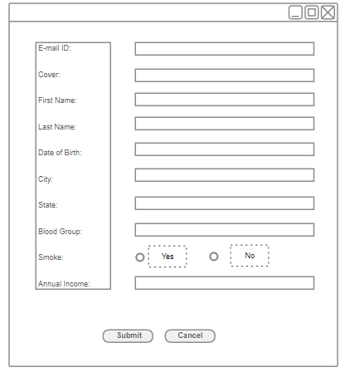

**Response:**

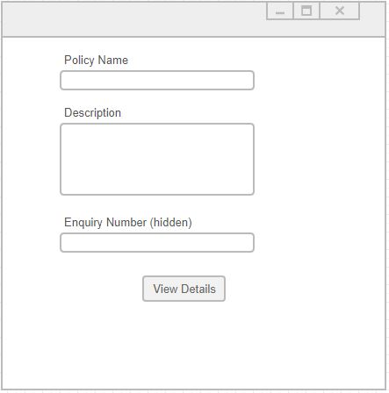

This form will be displayed once user clicks on “View Details” button on above form

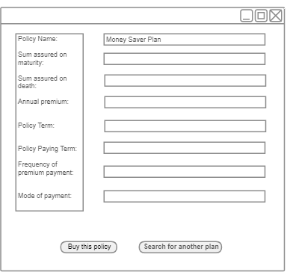

## Phase 2:

|  |  |  |
| --- | --- | --- |
| **Sr. No.** | **Requirement Title** | **Description** |
| 1 | User Account Page | User will login to his/her account and can see all enrolled policies |
| 2 | Policy Suggestion List | Customer will be suggested more policies and schemes as per the information provided when customer visits for first time to choose policy |
| 3 | Online Premium Payment | User will be able to pay premium online through payment page |
| 4 | Reminders | User will be reminded for all due payments through e-mail |

## Phase 3:

|  |  |  |
| --- | --- | --- |
| **Sr. No.** | **Requirement Title** | **Description** |
| 1 | Policy Management | User will be able to manage all enrolled policies through his/her account |
| 2 | Chat Bot | User will be provided with chat service once he/she logins to his account for all queries they have |

# Technology Stack

Below are the technologies that will be used for building the POC

|  |  |  |
| --- | --- | --- |
|  | **Technology Stack** | **Remarks** |
| Development | JDK 1.8 |  |
|  | Spring Boot | Application Framework |
|  | Spring REST API |  |
|  | Spring Data JPA |  |
|  | Hibernate |  |
|  | Swagger | API documentation |
|  | JBoss Drools | Rule engine |
|  | Feign | REST client |
|  | Powermock | test cases libraries |
|  | Mockito | test cases libraries |
|  | MySQL | Database |
|  | Maven | Build Management |
|  | Git | Repository |
|  | Jenkins | CI Tool |
| Others | ZUUL, Eureka | API gateway |
|  | Hystrix | Circuit breaker |
|  | NetFlix Ribbon | Load balancer |
|  | Apache Kafka | message broker |
|  | Sonarqube | code coverage, quality |
|  | Docker | Deployment container |
|  | Kubernates | Deployment container management |
|  | Liquibase - Database management |  |

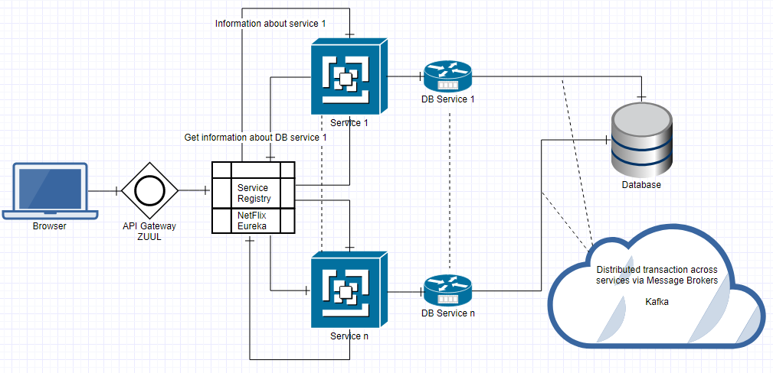

# Acronyms & Abbreviations

IMS – Insurance Management System

POC – Proof of Concept

# References

TBD